For Immediate Release

CHAMPION VADIM NEMKOV VS. NO. 5 JULIUS ANGLICKAS, NO. 1 RYAN BADER VS. NO. 2 COREY ANDERSON TO CO HEADLINE BELLATOR MMA 268: LIGHT HEAVYWEIGHT WORLD GRAND PRIX SEMIFINALS SATURDAY, OCT. 16, AT 10 P.M. ET LIVE ON SHOWTIME

Married Arizonans Benson and Maria Henderson to be featured
in separate bouts of fantastic 14-fight BELLATOR™ card
at the Footprint Center in Phoenix, Ariz.

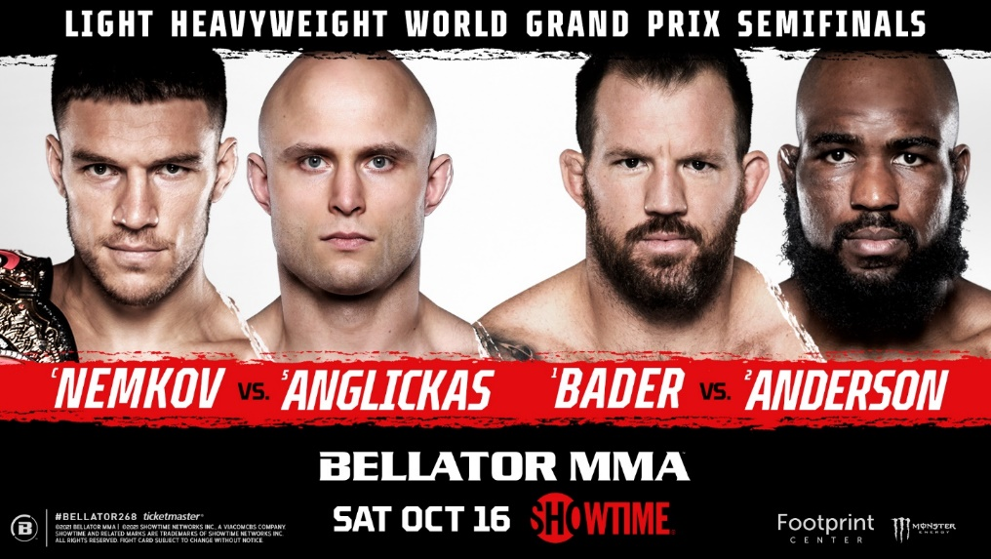

LOS ANGELES (Oct. 7, 2021) – Highlighting the second of three outstanding BELLATOR MMA events in October, current 205-lb. World Champion Vadim Nemkov (14-2) will battle No. 5-ranked contender Julius Anglickas (10-1), while BELLATOR Heavyweight World Champion/No. 1-ranked light heavyweight Ryan “Darth” Bader (28-6, 1 NC) squares off against No. 2 Corey Anderson (15-5) in the co-featured bouts of BELLATOR MMA 268: Light Heavyweight World Grand Prix Semifinals Saturday, Oct. 16, at 10 p.m. ET live on SHOWTIME from the Footprint Center in Phoenix.

SHOWTIME will televise the fantastic four-bout BELLATOR MMA 268: Light Heavyweight World Grand Prix Semifinals main card live at 10 p.m. ET. Additionally, all 10 action-packed preliminary fights will stream live three hours earlier at 7 p.m. ET on the BELLATOR MMA YouTube channel, SHOWTIME Sports YouTube channel and Pluto TV.

Tickets for BELLATOR MMA 268: Light Heavyweight World Grand Prix Semifinals are currently on sale at Ticketmaster.com and Bellator.com.

Fighting for the first time on the same card, married Phoenix residents Benson Henderson (28-10) and his wife, Maria Henderson (1-0) will be featured on the main card and preliminary portion, respectively. Maria will open the evening when she squares off against Collette Santiago in a strawweight battle of hard-hitting Arizonans. After cheering his bride on, No. 3-ranked lightweight Benson will return later in the night against former 155-pound titleholder Brent Primus (10-2). Born in Colorado Springs, Colo., Benson famously proposed to Maria in the cage following his 2013 victory over Gilbert Melendez in San Jose, Calif.

Nemkov, of Belgorod, Russia, captured the BELLATOR light heavyweight crown by defeating Bader via second-round TKO at BELLATOR 244 in August 2020. Currently riding an eight-fight winning streak, the ferocious 29-year-old sports seven first-round knockouts in 16 career contests. In his most recent outing, Nemkov successfully defended his light heavyweight belt by earning a tough unanimous decision over Phil Davis.

Anglickas, of St. Charles, Mo., replaced Anthony “Rumble” Johnson on short notice to challenge Nemkov. Hoping to ascend to the final of the Light Heavyweight Grand Prix with a victory and an opportunity to fight for the $1 million prize, the pride of Plunge, Lithuania, and official Light Heavyweight Grand Prix tournament alternate has defeated nine consecutive opponents after splitting his first two professional bouts.

Bader, of Chandler, Ariz., became the first BELLATOR fighter to hold belts in both the light heavyweight and heavyweight divisions at BELLATOR 214. He accomplished the rare feat by knocking out the legendary Fedor Emelianenko on punches at 35 seconds of the opening round to capture the BELLATOR Heavyweight World Grand Prix in January 2019. A two-time NCAA All-American wrestler during his collegiate career at Arizona State University, the Reno, Nev., native counts triumphs over Davis (twice), “Rampage” Jackson, Rashad Evans, and Keith Jardine, during his illustrious 14-plus-year MMA career.

Anderson, of Robbinsville, N.J., has vanquished six of his past seven opponents, including a third-round stoppage of Dovletdzhan Yagshimuradov at BELLATOR 257 six months ago in April 2021. In his first promotional appearance, the Rockford. Ill., native recorded a second-round TKO in November 2020 over Melvin Manhoef at BELLATOR 251.

The BELLATOR Light Heavyweight World Grand Prix commenced at BELLATOR 256 on April 9, 2021, when Bader defeated Lyoto Machida via unanimous decision, and Anderson dismantled Yagshimuradov in the tournament’s quarterfinal round at the Mohegan Sun in Uncasville, Conn. The following week featured current champion Nemkov defending his crown against former champion Phil Davis. The victors of Nemkov-Anglickas and Bader-Anderson will meet in a highly anticipated tournament final later this year.

Rounding out the four-bout SHOWTIME telecast will be the previously mentioned lightweight contest pitting Henderson against Primus, as well as a ferocious featherweight clash pitting veteran knockout artist Henry “O.K.” Corrales (18-6) against Ukrainian submission ace Vladyslav Parubchenko (16-2).

Spotlighting the 10-fight preliminary card will be a light-heavyweight bout between No. 10-ranked Swedish sensation Karl Albrektsson (12-3) and BELLATOR newcomer Dovletdzhan Yagshimuradov (18-6-1), as well as undefeated female brawlers Sumiko “Lady Samurai” Inaba (2-0) of Maui, Hawaii, and Canadian “Ruthless” Randi Field (2-0) in a featherweight showdown. Rounding out the preliminaries will be British Columbia’s own Lance Gibson Jr. (4-0) hoping to keep his unblemished professional record intact in a lightweight brawl against Raymond Pina (9-4) of Tucson, Ariz., and the always-dangerous Jaylon Bates (3-0) returning to the BELLATOR cage for the third time in 2021 when he battles Brazilian Raphael Montini (6-4, 1 NC) in a bantamweight brawl.

BELLATOR 268: Light Heavyweight World Grand Prix Semifinals
MAIN CARD:
Saturday, Oct. 16 – live on SHOWTIME
10 p.m. ET/7 p.m. PT

Light Heavyweight World Title Main Event: Champion-Vadim Nemkov (14-2) vs. No. 5-Julius Anglickas (10-1)
Light Heavyweight World Grand Prix Semifinal: No. 1-Ryan Bader (28-6, 1 NC) vs. No. 2-Corey Anderson (15-5)
Lightweight Bout: No. 3-Benson Henderson (28-10) vs. Brent Primus (10-2)
Featherweight Bout: Henry Corrales (18-6) vs. Vladyslav Parubchenko (16-2)

BELLATOR 268: Light Heavyweight World Grand Prix Semifinals
PRELIMINARY CARD:
BELLATOR MMA YouTube channel | SHOWTIME Sports YouTube channel | Pluto TV
Saturday, Oct. 16
7 p.m. ET/4 p.m. PT

Light Heavyweight Bout: No. 10-Karl Albrektsson (12-3) vs. Dovletdzhan Yagshimuradov (18-6-1)
Light Heavyweight Bout: Sullivan Cauley (1-0) vs. Deon Clash (1-0)
Lightweight Bout: Nick Browne (11-1) vs. Bobby Lee (12-6)
Middleweight Bout: Javier Torres (11-5, 1 NC) vs. Gregory Milliard (12-6)
Women’s Flyweight Bout: Sumiko Inaba (2-0) vs. Randi Field (2-0)
Lightweight Bout: Lance Gibson Jr. (4-0) vs. Raymond Pina (9-4)
Bantamweight Bout: Jaylon Bates (3-0) vs. Raphael Montini (6-4, 1 NC)
Welterweight Bout: Mukhamed Berkhamov (14-1) vs. Jaleel Willis (15-2)
Amateur Strawweight Bout: Maria Henderson (1-0) vs. Collette Santiago (0-2)

*Card subject to change.

Please visit Bellator.com for additional information.

****
Updated schedule of BELLATOR events
Sat. Oct. 16 // BELLATOR 268: Light Heavyweight World Grand Prix Semifinals // Footprint Center // Phoenix, AZ
Sat. Oct. 23 // BELLATOR 269: Fedor vs. Johnson // VTB Arena // Moscow, Russia
Fri. Nov. 5 // BELLATOR 270: Queally vs. Pitbull 2 // 3Arena // Dublin, Ireland
Fri. Nov. 12 // BELLATOR 271: Cyborg vs. Kavanagh // Seminole Hard Rock Hotel & Casino // Hollywood, FL

About BELLATOR
BELLATOR MMA is a leading global mixed martial arts organization featuring many of the best fighters in the world. Under the direction of veteran fight promoter Scott Coker, BELLATOR events take place in major cities worldwide and can be seen on television in over 160 countries to an available audience of over one billion people. In the United States, BELLATOR can be seen on SHOWTIME. BELLATOR is comprised of an executive team that includes top industry professionals in television production, live event orchestration, fighter development/relations, venue procurement, sponsorship creation/development, international licensing, marketing, advertising, publicity, and commission relations. BELLATOR is based in Hollywood, Calif. and owned by entertainment giant ViacomCBS, home to the world's premier entertainment brands that connect with audiences through compelling content across television, motion picture, online and mobile platforms.

About SHOWTIME
Showtime Networks Inc. (SNI), a wholly owned subsidiary of ViacomCBS Inc., owns and operates the premium television networks SHOWTIME®, THE MOVIE CHANNEL™ and FLIX®, and also offers SHOWTIME ON DEMAND®, THE MOVIE CHANNEL™ ON DEMAND and FLIX ON DEMAND®, and the network's authentication service SHOWTIME ANYTIME®. Showtime Digital Inc., a wholly owned subsidiary of SNI, operates the stand-alone streaming service SHOWTIME®. SHOWTIME is currently available to subscribers via cable, DBS, and telco providers, and as a stand-alone streaming service through Amazon, Apple®, Google, LG Smart TVs, Oculus Go, Roku®, Samsung Smart TVs, Xbox One and PlayStation®4. Consumers can also subscribe to SHOWTIME via Amazon’s Prime Video Channels, Apple TV Channels, AT&T TV Now, FuboTV, Hulu, The Roku Channel, Sling TV, and YouTube TV. Viewers can also watch on computers at Showtime.com. SNI markets and distributes sports and entertainment events for exhibition to subscribers on a pay-per-view basis through SHOWTIME PPV®. For more information, go to www.SHO.com.

